|  |
| --- |
| Happy  Day |

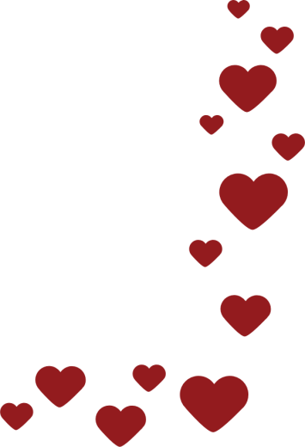

|  |
| --- |
| **Mom,** |